Participant Information Sheet

Date that data collection will start:
01/10/2026

Project Title
Human Digital Twin Intelligence: Integrating Multimodal AI and Generative Models for Non-Intrusive Health and Activity Monitoring.

Kia ora,

You are invited to participate in a research study being conducted by researchers from Auckland University of Technology (AUT), New Zealand. The study explores how artificial intelligence (AI) can combine depth cameras, wearable sensors, radar and fixed video ground-truth information to understand everyday human movements and estimate heart-rate and breathing-rate information for research purposes.

The research team includes A/Prof. Sira Yongchareon, Dr Anuradha Singh and Dr Yanbin Liu from the Department of Data Science and Artificial Intelligence, School of Engineering, Computer and Mathematical Sciences. Research assistants may help with data collection under the supervision of the research team. The study is supported by AUT research funding.

What is the purpose of this research?
The purpose of this research is to develop and evaluate AI models for human activity recognition and non-contact vital-sign estimation. The study will collect synchronised data from dept cameras, wearable motion sensors, a Hexoskin smart vest, mmWave radar and a fixed video recording system during common functional movements. The video recording is used only to label and validate the sensor data.

We expect to recruit approximately 30 adult participants in New Zealand. The findings may contribute to future health, rehabilitation, aged-care and independent-living technologies. The findings may also be used for academic publications, conference presentations, research reports and future research proposals.

How was I identified and why am I being invited to participate in this research?
You may have received this Information Sheet because you saw a recruitment flyer and expressed interest in taking part. You are not being individually invited because of your relationship with any researcher, and participation is completely voluntary.

You are being invited because you may meet the study criteria. To take part, you must be aged 18 years or older and able to safely perform common functional movements such as sitting, standing, walking, step movement, squatting, lunging and bending.

You should not take part if you have a current injury, health condition, mobility limitation, skin sensitivity, or other concern that would make the movements or sensor attachment unsafe or uncomfortable. Recruitment will not target students currently taught, supervised, assessed or managed by members of the research team.

How do I agree to participate in this research?
If you are interested in taking part, please contact the research team using the contact details at the end of this Information Sheet. The research team will answer any questions and arrange a suitable time for a laboratory session. Before the session begins, you will be asked to read this Information Sheet and sign a Consent Form.

Your participation is voluntary. Whether you choose to participate will neither advantage nor disadvantage you. You may withdraw from the study at any time by informing the researcher, and you do not need to give a reason.

Because your research data will be coded/de-identified rather than anonymous during the active study period, the research team will hold a separate participant-code key. This means your data can be identified and withdrawn if you ask for this before the data have been fully anonymised, aggregated, destroyed or released as part of an approved de-identified dataset. Once data have been fully anonymised, aggregated or released in de-identified form under an approved Data Release Agreement, removal may no longer be possible.

What will my participation involve?
Participation involves one laboratory session at the AUT WZ Level 1 Engineering Laboratory. The session is expected to take approximately one hour, including explanation of the study, consent, private changing, sensor fitting, calibration, activity trials, rest breaks, sensor removal and debriefing.
During the session, you will be asked to:

- wear a Hexoskin smart vest, which records research-quality heart-rate and breathing-rate-related signals;
- wear five small wearable inertial measurement unit (IMU) sensors on the lower back, thigh, waist, dominant wrist and dominant ankle;
- allow Depth cameras to record 3D point-cloud data of your activity trials
- allow a mmWave radar device positioned in the laboratory to collect non-contact radar signals during the activity trials; and
- allow a fixed camera to record your activity trials for ground-truth activity labelling and sensor validation;
- perform common functional movements such as sitting, standing, walking, fast-paced walking, sit-to-stand, step-ups, squats, lunges, carrying a light object and bending to pick up a light object.

An IMU Sensor A Hexoskin Smart Vest

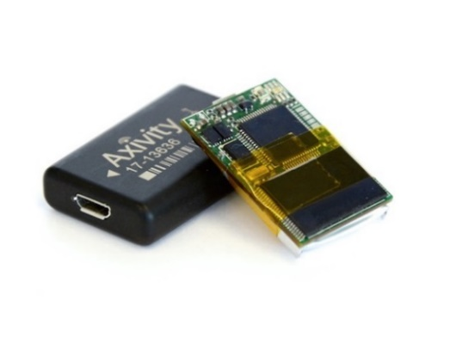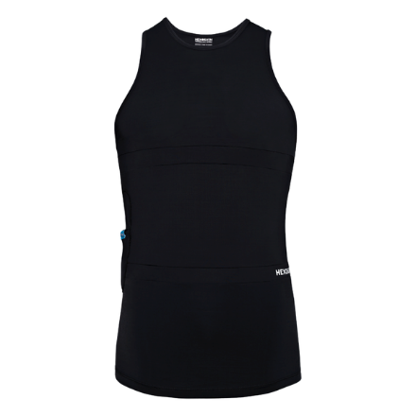

The lower-back and thigh IMU sensors may be attached to the skin using medical-grade adhesive/tape and transparent overlay tape. The waist sensor is secured with an elastic belt, the wrist sensor with a wristband, and the ankle sensor with an ankle strap. You may ask for any sensor to be adjusted or removed at any time.

You will not wear a camera. The video recording system is fixed in the laboratory and is used only to label the activity being performed and to check synchronisation with the sensor and depth data. You may ask for the camera and/or radar to be turned off at any time. You may also pause, rest, skip any activity or stop the session without giving a reason.

What are the benefits?
There may be no direct personal benefit to you. Your participation may help the research team develop safer and more accurate AI methods for understanding human activity and vital signs using non-intrusive sensing. In the longer term, this work may support applications in activity monitoring, rehabilitation, fall-risk assessment, aged care and independent living.

The research will also benefit the researchers by supporting the development and evaluation of AI models, research publications, conference presentations, research datasets, and future research proposals.

What are the costs?
The main cost to you is your time and any travel or parking costs associated with attending the AUT laboratory. The session will take approximately one hour.

You will receive a $100 voucher as a token of appreciation for your time and travel. The voucher is not intended to pressure you to take part. If you attend and begin the session but later decide to withdraw, you will still receive the voucher.

There are no costs for using any technology in this study. You do not need to install any app, provide credit card details or use your own device.

Will the results of the study be published?
The results of this research may be published in peer-reviewed academic journals, conference papers, research reports and presentations. A plain-language summary may also be made available to participants who request it.

Research outputs may include de-identified research datasets, trained AI models, technical evaluation results, academic publications, conference presentations and plain-language summaries. Raw video, names, contact details, consent forms, facial images and directly identifiable information will not be included in publications, presentations or released datasets.

What are the discomforts and risks?
The study involves minimal physical risk, but you may experience temporary discomfort from wearing the Hexoskin vest, adhesive tape, straps or IMU sensors. There is also a small risk of skin irritation from adhesive/tape, tiredness from repeated movements, or discomfort with being video-recorded in the laboratory.

The activity tasks are common functional movements and will be performed in a controlled laboratory setting. However, as with any movement task, there is a small risk of imbalance, strain or minor injury. The study is not suitable for people who have a current injury, health condition, mobility limitation, skin sensitivity or other concern that may make the activities unsafe or uncomfortable.

Heart-rate and breathing-rate data are collected for research validation only. This study does not provide clinical assessment, diagnosis, treatment, monitoring or individual medical advice.

How will these discomforts and risks be alleviated?
You may take breaks, skip any activity, ask questions, request sensor adjustment or removal, ask for the camera and/or radar to be turned off, or stop the session at any time. The research team will monitor for discomfort, fatigue, loss of balance or sensor irritation, and activities will be stopped if you or the researcher has any safety concern.

A private changing area will be provided for the Hexoskin vest. Vests are available in different sizes. Equipment will be cleaned or sanitised between participants. You may request a same-gender researcher where assistance with sensor placement or vest fitting is needed.

If you have any health concerns before or during the study, please inform the researcher. If you have concerns about your health after the session, you should seek advice from an appropriate health professional.

What will happen to information about me?
- The study will collect your name and contact details for scheduling and communication, a signed Consent Form, a participant code, wearable IMU sensor data, Hexoskin heart-rate and breathing-rate-related data, mmWave radar data, fixed video recordings of the activity trials, activity labels, trial timing information and non-identifying metadata such as sensor location and activity type.

- Your name, contact details, Consent Form and participant-code key will be stored separately from the research data. Research data files will use a participant code rather than your name. During the active study period, the approved research team may use the participant-code key to link coded/de-identified data back to you if you request withdrawal.

- Raw video is identifiable biometric data. It will be used only by the approved AUT research team for activity labelling, synchronisation checking and validation of the sensor data. Raw video will not be shared outside the approved research team, will not be released externally, and will not be included in any public or controlled dataset.

- All research data will be stored securely on AUT-managed systems with access restricted to the approved research team. Identifiable information, including raw video, consent forms and the participant-code key, will be securely destroyed after six years unless AUT policy or law requires otherwise. Electronic files will be securely deleted and hard-copy records will be securely shredded. Raw video data will be destroyed once the sensor data is validated

- If you consent, de-identified, non-video, sensor-derived data and associated activity labels may be used in future ethically approved research and may be shared with approved researchers under an AUT-approved Data Release Agreement. Such data will not include names, contact details, consent forms, raw video, facial images or directly identifiable information. Any data release will prohibit re-identification attempts and unauthorised redistribution.

- There is a very small risk that de-identified data could be linked with other information in the future. To reduce this risk, the released dataset will exclude raw video, facial images, names, contact details and other directly identifying information. Identifiable information will only be disclosed outside the study with your permission, or as required by law.

- By signing the Consent Form, you agree to the use of your information as described in this Information Sheet. You have the right to ask to access or correct information held about you, subject to applicable privacy and research requirements.

Use of New Technologies (e.g. Artificial Intelligence, Machine learning, Health Apps).
This study uses AI and machine-learning methods to analyse wearable sensor, radar and activity-label data. Use of these technologies is a mandatory component of the study because the purpose of the research is to develop and evaluate AI models for activity recognition and vital-sign estimation.

The AI models will be used for research analysis only. They will not make clinical decisions about you, will not provide a diagnosis, and will not be used for treatment or individual health monitoring. The technologies used in this study do not require you to install software, create an account, provide payment details, or share information with social media or advertising services.

The research team will de-identify data by replacing your name with a participant code and by storing the participant-code key separately from research data. Only the approved research team will have access to identifiable information. Analysis will be performed using AUT-managed systems and research-team-developed analysis scripts/software.

Māori data sovereignty
This study does not specifically target Māori participants or collect Māori-specific information. However, Māori participants may choose to take part, and we recognise that data provided by Māori participants should be treated with respect and care.

Identifiable information will remain under restricted access within AUT-managed systems. Any future use or sharing will be limited to de-identified, non-video sensor-derived data under an approved Data Release Agreement and will not include names, contact details, facial images or raw video. You may ask questions about how your information will be used before deciding whether to participate.

What opportunity do I have to consider this invitation?

You may take as much time as you need to consider this invitation before deciding whether to participate. You are encouraged to read this Information Sheet, discuss it with others if you wish, and ask the research team any questions. Participation will only be arranged after you have confirmed that you would like to take part.

Will I receive feedback on the results of this research?
I will send a summary of the research to you at the end of the study, if you request this. I will send you a copy of your individual results if you indicate this on the Consent Form.

What do I do if I have concerns about this research?
Any concerns regarding the nature of this project should be notified in the first instance to the project lead, A/Prof. Sira Yongchareon, sira.yongchareon@aut.ac.nz, +64 9 921 9999 ext. 5002.

Concerns regarding the conduct of the research should be notified to the Executive Secretary of AUTEC, ethics@aut.ac.nz, (+649) 921 9999 ext. 6038.

Who do I contact for further information about this research?
Please keep this Information Sheet and a copy of the Consent Form for your future reference. You are also able to contact the research team as follows:

Researcher Contact Details:
- Dr Anuradha Singh, Department of Data Science and Artificial Intelligence, AUT. Email: anuradha.singh@aut.ac.nz. Phone: +64 9 921 9999 ext. 26128.
- Dr Yanbin Liu, Department of Data Science and Artificial Intelligence, AUT. Email: yanbin.liu@aut.ac.nz. Phone: +64 9921 9999 Ext. 31934

Project Supervisor Contact Details:
A/Prof. Sira Yongchareon, sira.yongchareon@aut.ac.nz, +64 9 921 9999 ext. 5002.

Approved by the Auckland University of Technology Ethics Committee on 12/06/2026, AUTEC Reference number: 26/144.

